**WE CAN TELL AND WE WILL TELL**

**Information for women with disabilities about identifying and reporting abuse**

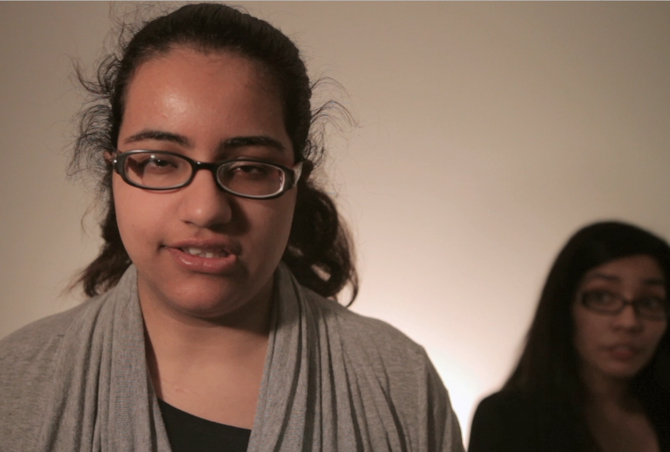

**What constitutes abuse?**



The first step is to be able to identify the abuse in our lives. Abuse can be:

**Physical Force**

If you are hit, kicked, slapped, punched or beaten, you are being physically abused. If a person who is supposed to be providing care for you uses physical force while feeding, dressing or bathing you, you are being abused by your caregiver.

**Sexual Violence**

If you are raped or forced to engage in any sexual behaviour that you do not want, even by your partner, boyfriend or husband, you are being sexually abused. You may experience unwanted sexual actions by a caregiver. For example, if your caregiver touches you sexually during your bathing or toilet routine, that is abuse.

**Caregiver Neglect**

If you are denied assistance to use the washroom, get out of bed, have food or be bathed, it is unacceptable, and it is abuse. If someone threatens to take away your assistive device such as a hearing aid, wheelchair or walker, that is abuse.

**Verbal Abuse and Threats**

If anyone—an attendant, support worker, “friend” or family member—continually tells you that you are incapable of doing anything meaningful with your life because of your disability; that is abusive. If you experience disrespectful treatment from shelter workers, social workers, medical staff or any other person that is being paid to help you, it is abuse.

**It is abuse when someone threatens to:**

* Physically or sexually harm you
* Leave you without being fed or cared for
* Leave you in wet or soiled clothing or bed sheets for a long period of time
* Leave you on the toilet or in the bath too long
* Leave and take the children
* Put you in an institution

Threats are abuse.

**Financial Abuse**

If someone tries to control or use your money against your wishes or without your consent, that is abuse.

**Racism, Sexism, Homophobia and Classism as Abuse**

Discrimination is even worse when, as women with disabilities and Deaf women, we also belong to another group that faces barriers. When someone says bad things to you or treats you badly because you are young, old, of a minority racial group, or you identify as lesbian, bisexual, trans or queer or because you are poor - that is abuse.

**Ableism**

Ableism is a form of abuse and prejudice that happens when people with disabilities are treated as though they are not as good as people without disabilities.

**Cyber Bullying**

Cyber bullying is when through e-mail, internet chat rooms and electronic gadgets like cellphone cameras, cyber bullies spread hurtful images and/or messages.

**Resource list of Crisis Hotlines**

**Ontario**

**Assaulted Women’s Helpline**: Provides anonymous and confidential crisis counseling, informational and emotional support to women. (Toronto, ON)

<http://www.awhl.org/>

Toll Free: 1-866-863-0511

Toll Free TTY: 1-866-863-7868

**Talk for Healing**: Talk4Healing is a helpline available to all Aboriginal women living in urban, rural and remote communities, both on and off reserve, throughout Northern Ontario.

<http://www.talk4healing.com/>

Telephone: 1-855-554-4325

**Mental Health Crisis Line:** A 24/7 helpline to assist people experiencing a mental health problem or crisis. (Ottawa, ON)

<http://www.crisisline.ca/home.htm>

Telephone: 613-722-6914

Toll Free: 1-866-996-0991

**Fem'aide:** Provincial helpline for francophone women in Ontario dealing with violence

<http://www.femaide.ca/>

Telephone: 1-877-336-2433

TTY: 1-866-860-7082

**British Columbia**

**Battered Women's Support Services**: Provides education, advocacy and support services to assist women. (Vancouver, BC)

<http://www.bwss.org/>

Crisis line: 604-687-1867

Toll Free: 1-855-687-1868

**Greater Vancouver Crisis Line:** Non-profit organizing that provides emotional support to youth, adults and seniors in distress. (Greater Vancouver, BC)

Telephone: 604-872-3311

Toll Free: 1-866-661-3311

TTY: 1-866-872-0113

**Domestic Violence Helpline (Victim Link):** Helpline designed to provide information and support to those experiencing domestic violence.

<http://www.domesticviolencebc.ca/>

Phone: 604-875-0885

Toll Free TTY: 1-800-563-0808

**Surrey Women's Center:** Offer a range of crisis services to victims of domestic violence, sexual assault, child abuse and other forms of family violence. 24/7 helpline services provided. (Surrey, BC)

<http://surreywomenscentre.ca/>

Telephone: 604-583-1295

**WAVAW:** Works to end violence against women through various support programs and services including an emotional and informational support 24-hour crisis line.

<http://www.wavaw.ca/>

24-Hour Crisis Line: 604-255-6344

Toll free: 1-877-392-7583

**North Shore Crisis Services Society:** NSCSS is a transition house and also provides related support services. (North Vancouver, BC)

<http://nscss.net/>

Telephone: 604-987-3374

**BC Coalition to Eliminate Abuse of Seniors:** Helpline providing emotional and legal information and referral for seniors experiencing abuse. (Vancouver, BC)

<http://bcceas.ca/>

Telephone: 604-437-1940

Toll free: 1-866-437-1940

TTY: 604-428-3359

TTY Toll free: 1-855-306-1443

**Alberta**

**Crisis Association of Vegreville:** General helpline for those experiencing a problem and require assistance. (Vegreville, Alberta)

Telephone: 1-780-632-2233

Toll Free Helpline: 1-780-632-7070

**Family Violence Info Line:** 24/7 helpline in over 170 languages to provide support and advice for people experiencing family violence.

Telephone: 780- 310-1818

**Edmonton Women’s Shelter Ltd.**: A non-profit agency with three shelters for women with or without children leaving domestic violence situations. A 24 hour support and information line is provided. (Edmonton, AB)

<http://www.winhouse.org/>

Telephone: 780-479-0058

**St. Paul’s Crisis Center:** Non-profit organization that provides safe and supportive environments for women with or without children who are experiencing family violence. 24/7 crisis line available for information and emotional support. (St. Paul, AB)

<http://www.stpaulcrisiscentre.ca/>

Telephone: 645-5195

Toll Free: 1-800-263-3045

**Camrose Women's Shelter Society:** Women’s shelter proving safe environments for women and children needing protection from family violence. 24 hour crisis line for additional assistance. (Camrose, AB)

<http://brigantiaplace.org/>

Phone: 780-672-1035 (main line)

Toll Free Crisis Line: 1-877-672-1010

**Calgary Women’s Emergency Shelter:** Offers support to individuals and families fleeing family violence and abuse. The 24-hour helpline provides support, information and access to programs at the shelter. (Calgary, AB)

<http://www.calgarywomensshelter.com/home>

Telephone: 403-234-7233

Toll Free: 1 (866) 606-7233

**Sucker Creek Women’s Emergency Shelter:** Provides range of services for women and children experiencing abuse and assault including a 24-hour crisis line.

(Edmonton, AB)

Telephone: 780-523-2929

Crisis Phone: 780-523-4357

Toll Free: 1-866-523-2929

**Saskatchewan**

**La Ronge 24-Hour Crisis Line:** General crisis line for men and women in crisis in La Ronge, Saskatchewan. (La Ronge, SK)

Crisis Line: 306-425-4090

**Moose Jaw Domestic Violence Crisis Line:** Moose Jaw offers a transition house for women and children affected by family violence and abuse. The crisis line offers 24-hour emotional, informational and referral support to women. (Moose Jaw, SK)

<http://www.mj-transitionhouse.com/>

Hotline: 306-693-6511

**Prince Albert Domestic Violence Crisis Intervention:** General crisis line for those experiencing domestic violence. (Prince Albert, SK)

Crisis Line: 306-764-1011

**Yorkton Domestic Violence Crisis Line:** General crisis line for those experiencing domestic violence in Yorkton. (Yorkton, SK)

Crisis Line: 1-888-783-3111

**(Regina) Crisis/Suicide Line:** Provides 24-hour social and health crisis response to community of Regina. (Regina, SK)

<http://www.mobilecrisis.ca/>

Telephone: 306-757-0127

Crisis Line: 306-525-5333

**Manitoba**

**Toll-Free Province Wide Domestic Abuse Crisis Line (24 hours)**: General crisis line for people experiencing domestic violence and abuse in the province of Manitoba.

Toll Free: 1-877-977-0007

**Klinic Crisis Line:** Offers confidential counseling, support and referral to people in crisis.

<http://www.klinic.mb.ca/>

Crisis Line: (204) 786-8686

Toll free: 1-888-322-3019

TTY (204) 784-4097

**Northwest Territories**

**NWT Help Line:** General helpline there to provide support to those in crisis.

Telephone: 1-800-661-0844

**Nunavut**

**Nunavut Kamatsiaqtut Help Line:** Provides anonymous and confidential counseling for northerners in crisis.

<http://www.nunavuthelpline.ca/>

Telephone: 867-979-3333

Toll Free: 1-800-265-3333

**Quebec**

**Domestic Violence Hotline:** Provides anonymous and confidential domestic violence services via telephone or email. (Montreal, QC)

<www.sosviolenceconjugale.ca>

Telephone: 514-873-9010

Toll free: 1-800-363-9010

**Newfoundland**

**Hope Haven Transition House Crisis Line:** Provides confidential and safe emergency shelter to women and children who are experiencing violence and abuse. 24-hour crisis line offers information, emergency planning and emotional support. (Labrador City, NL)

<http://www.hopehaven.ca/>

Crisis Line: (709) 944-6900

Toll Free: 1-888-332-0000

**Nova Scotia**

**Helpline**: General helpline for people experiencing crisis in Nova Scotia.

Toll Free: 1-877-521-1188

TTY: 1-855-443-2660

**Yukon**

**Kaushee's Place / Yukon Women's Transition Home:** Offers shelter, outreach, support and advocacy for women and their children fleeing abuse.

<http://www.womensdirectorate.gov.yk.ca/shelters.html>

Crisis Line: 867-668-5733 (collect calls accepted from outside Whitehorse)

Telephone: 867-633-7720

**Tips on Safety Planning and Steps to follow if in crisis:**

Always remember if you are in immediate danger call 911- the police. If you are able to dial the phone but can’t communicate, remember to stay on the line – do not hang up. Give the following information clearly if you are able:

* your name;
* the location you are at;
* that you are being attacked;
* that you are afraid you are going to be hurt or you are afraid for your life; and
* where your attacker is and whether he has a weapon or access to weapons.

If you have time to plan ahead, the following steps can help you get out of an abusive situation.

**Make a decision** – You have to be willing to make a change in your life to get out of an abusive situation, knowing that you are not alone.

**Talk to someone about it** – It is very helpful to talk about your situation with someone that you trust - a friend or relative, a spiritual leader, a doctor, or a counsellor.

**Protect Yourself** - If you decide to stay, you should have an emergency and personal safety plan.

**Know what to do in an Emergency** – Be prepared to act quickly. Make an emergency plan. Tell someone you trust that you may need to activate your emergency plan. This person can support you with the following actions:

* Plan ahead of time where you can go to be safe, by making just one phone call.
* Work out a code word so that the person you call will know that this is you, if you are in crisis.
* Contact a shelter ahead of time and see if they can accommodate your disability needs.
* Get legal advice - Call a community legal clinic even before there is an emergency.
* Pre-arrange accessible transportation.
* Make photocopies of all your identification and important documents and keep them in a safe place where you can find them quickly.
* Pack an emergency bag, including all these important documents (i.e. Health Cards, birth certificates, marriage certificates, immigration/citizenship papers, passports, copies of your lease, mortgage, your address/phone book, etc.)

**Use the Internet Safely**

The Internet is a really useful way to get important information, but it can also leave a record of the websites and information that you have been looking for. If your abuser is very knowledgeable about computers, he may be able to see which websites you have looked at. There are things that you can do to delete traces of what websites you have been visiting. But it may just not be safe to use a computer at home. You might want to use the computer at the public library, a school, an internet cafe, or your workplace. Please visit <http://ywcasudbury.ca/resources/343-2/> for more information about internet and email safety.

**What the D.A.I. case is and why it is important**

On February 10, 2012 the Supreme Court of Canada announced a decision in a court case called ["D.A.I.",](http://leaf.ca/cases/r-v-d-a-i/) that recognized the right of people with disabilities to be believed when they report sexual assault and abuse.

D.A.I. involved a young woman with an intellectual disability who reported that her step-father had sexually assaulted her. At the first court case, the judge did not believe that the young woman understood what an "oath” or a “promise” to tell the truth was, so they dropped the case and the stepfather was freed from the charges.

The DisAbled Women's Network (DAWN) Canada and the Women's Legal Education & Action Fund (LEAF) got involved stating that this was not fair and that they needed to hear this case again. DAWN and LEAF stated that women with intellectual and other "mental" based disabilities should be able to testify against their abusers, even if they can't explain what truth or promise means.

The Supreme Court of Canada agreed with DAWN and LEAF and ordered a new trial.

The D.A.I case recognizes that women and men with intellectual and other disabilities should be able to testify if they can describe the abuse that they experienced. Before this decision, women and men with disabilities, especially intellectual disabilities, were not seen as being truthful about their experiences of abuse. This decision was very important because it recognizes that regardless of how a person communicates, they should be able to go to court and report and describe the abuse that they experienced. This case supports our rights as people with disabilities to be believed and to make sure that our abusers are put on trial and if found guilty, punished for their crime.



DisAbled Women's Network of Canada/

Réseau d’action des femmes handicapées du Canada

110, Sainte-Thérèse #505

Montréal (Quebec) H2Y 1E6

Phone : (514) 396-0009

Toll free : 1-866-396-0074

Fax : (514) 396-6585

[](http://www.youtube.com/user/DAWNRAFHCanada/feed) [](https://twitter.com/dawnrafhcanada) [](https://www.facebook.com/DawnRafhCanada)

Funding for this project was received from the Victims Fund of the Department of Justice Canada