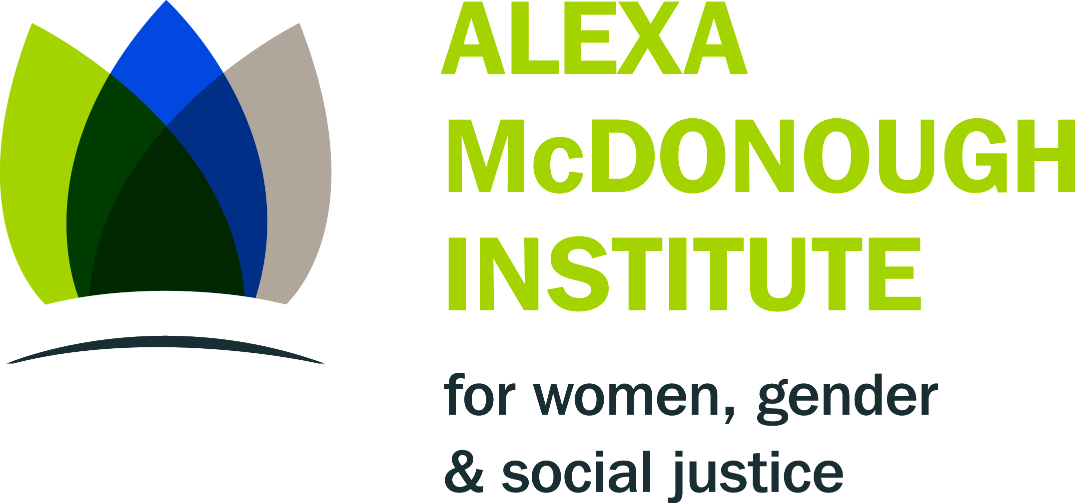

Women Boldly Visioning our Future:

Inclusion and Access

Join Bonnie Brayton, recently named one of Canada’s 23 Women of Bold Vision and National Executive Director of DAWN-RAFH Canada (DisAbled Women’s Network of Canada), along with a panel of Nova Scotia women with disabilities to share their bold visions on leadership and mentoring between and among women, to imagine what access and inclusion can be and what it will take to make it happen.

Panel members include: Emily Duffett, Nova Scotia League for Equal Opportunities, Julieanne Acker-Verney, Mount Saint Vincent University Women and Gender Studies, and Anne MacRae, Executive Director of the Nova Scotia Disabled Persons Commission.

Tuesday September 30, 2014 6:30 – 9 pm
Mount Saint Vincent University
Seton Academic Centre 4th floor
Margie O’Brien Faculty Lounge, Room 404, 405

Sponsored by:
Nancy’s Chair in Women’s Studies
Alexa McDonough Institute for Women, Gender and Social Justice
Mount Saint Vincent University
Light refreshments will be available

Please contact mary.lou.ohara@msvu.ca by September 25 for disability related accommodations.

