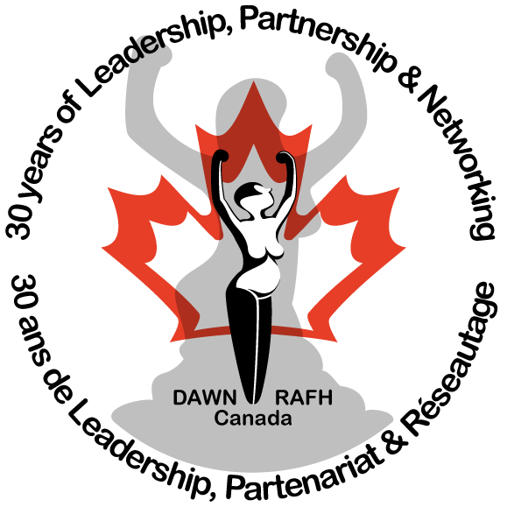
DisAbled Women’s Network of Canada
Réseau d'action des femmes handicapées du Canada

Speaking Notes

Be strong. Be safe. Be heard.
Share Your Voice: Community Forum for Robust Safeguards in
Bill C-14 Thursday, Ottawa, June 16th
Presented by
Bonnie Brayton
National Executive Director
DAWN Canada

June 16, 2016

Leadership, Partnership & Networking

ABOUT THE DISABLED WOMEN’S
NETWORK OF CANADA (DAWN-RAFH
CANADA)

DisAbled Women’s Network (DAWNRAFH) Canada is a national, feminist, cross-disability organization whose mission is to end the poverty, isolation, discrimination and violence experienced by Canadian women with disabilities and
Deaf women. DAWN-RAFH is an organization that works towards the advancement and inclusion of women and girls with disabilities and Deaf women in Canada. Our overarching strategic theme is one of leadership, partnership and networking to engage all levels of government and the wider disability and women’s sectors and other stakeholders in addressing our key issues.

Contact:
110, rue Sainte-Thérèse, #203
Montréal, (Québec)
H2Y 1E6
Telephone: (514) 396-0009
Fax: (514) 396-6585
Toll free (Canada): 1-866-396-
0074
Email: admin@dawncanada.net
Web : www.dawncanada.net

Copyright : 2016 DisAbled Women’s Network of Canada

Thank you all for coming today and thank you to our community partners at the Canadian Association for Community Living , the Council of Canadian with Disabilities and Ellen from the National Network for Mental Health.

I would like to acknowledge the traditional lands of the Algonquin Peoples where we are gathered and the traditional lands of Treaty 7 of First Nations.

The DisAbled Women’s Network of Canada’s (DAWN Canada) mission is to end the poverty, isolation, discrimination and violence experienced by women disabilities and Deaf women.

DAWN Canada has advocated on behalf of the interests of women with disabilities and Deaf women as a party intervener before the Supreme Court of Canada in over a dozen cases. DAWN Canada has presented legal argument on both Section 15 of the Charter and Human Rights cases on behalf of persons with disabilities that have brought the perspective and advanced the rights of women with disabilities

On June 22nd, we will have completed 30 years in service to Canadian women and girls with disabilities. In preparing my notes for today, I wish to begin with an excerpt from a DAWN Canada publication from 1995, about a study funded by the Family Violence Prevention Division of Health Canada
Masuda, S. (1995). DON’T TELL ME TO TAKE A HOT BATH: Resource Manual For Crisis Workers. Vancouver: Family Violence Prevention Division Health Canada, Health Canada and Human Resources Development Canada.
"Women with disabilities often feel like burdens to the family, and many are abused and neglected. These are the women who are most susceptible to suicide and suicide from covert or blatant persuasion. (21.7%) of Women in this survey had been told that they would be better off dead, and an additional (26.2%) had been told that it would have been better if they had never been born. Sixteen percent of (16%) women had experienced both sentiments.”

In the 20 years since that report was written, we know that women with disabilities continue to be vulnerable because of societal attitudes and norms which view us as inferior and devalue our lives

In her brief to the joint Committee on Physician Assisted Dying earlier in this process, our President Carmela Hutchison said:

“We do not have Capital Punishment in this country, nor do we extradite offenders to countries who do, because we are concerned that we may inadvertently execute an innocent person and cannot devise adequate safeguards to prevent this. Yet in the name of individual rights, our Supreme Court believes that we can. The Carter v. Canada decision compels governments and Canadian society as a whole, to make rapid decisions on matters Canadians have not had proper time to fully understand or consider.”

We are very grateful to all our partners today but wish to draw particular attention to the very important work that CACL are doing in response to OUR new reality.

The Vulnerable Person Standard/Network and the common sense and stepped approach the Government and Parliament are presently proposing are the ONLY things standing between our worst fears and the reality that Bill C14 is going to create an even higher risk to women and girls with disabilities.

We invite Parliamentarians, Senators and all Canadians to review our Brief which provides specific and clear recommendations and compelling evidence from a long history of working on individual and systemic violence. It also confirms our support for a framework for monitoring and implementation that has been developed by experts through the Vulnerable Persons Standard.

Sue Rodriguez and Lee Carter will be remembered as women with disabilities who made an important difference in advancing the rights of people with disabilities as individuals who have the same rights to personhood and decision making as any other person.
If we lived in a Canada where the “collective” rights and freedoms of people with disabilities were already entrenched, where the battles against systemic sexism, racism and ableism were won, we would not be asking all of you, asking Parliament, our Senate and our Prime Minister to continue to dialogue with Canadians.

Additional information:

Here are links to our Brief and the work of the Vulnerable Persons Network:
French: http://www.dawncanada.net/?attachment_id=1823
English: http://www.dawncanada.net/?attachment_id=1822

Vulnerable Person Network: http://www.vps-npv.ca/

For further information or interviews contact:

Hanane Khales
Communications Coordinator
Toll free/Sans frais: 1-866-396-0074
Téléphone: (514) 396-0009 EXT. 2505
Fax/Télécopieur: (514) 396-6585
communications@dawncanada.net

