WE CAN TELL AND WE WILL TELL
Information for women with disabilities about identifying and reporting abuse

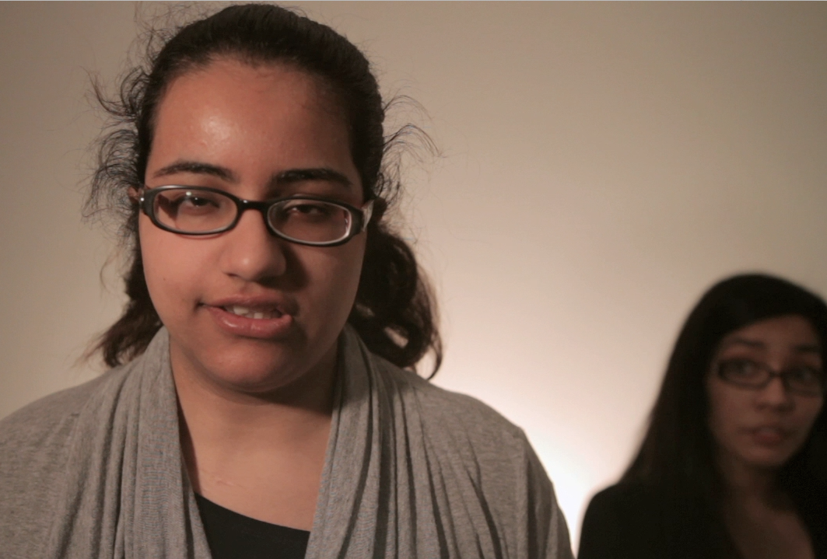


What constitutes abuse?

The first step is to be able to identify the abuse in our lives. Abuse can be:

Physical Force
If you are hit, kicked, slapped, punched or beaten, you are being physically abused. If a person who is supposed to be providing care for you uses physical force while feeding, dressing or bathing you, you are being abused by your caregiver.

Sexual Violence
If you are raped or forced to engage in any sexual behaviour that you do not want, even by your partner, boyfriend or husband, you are being sexually abused. You may experience unwanted sexual actions by a caregiver. For example, if your caregiver touches you sexually during your bathing or toilet routine, that is abuse.

Caregiver Neglect
If you are denied assistance to use the washroom, get out of bed, have food or be bathed, it is unacceptable, and it is abuse. If someone threatens to take away your assistive device such as a hearing aid, wheelchair or walker, that is abuse.

Verbal Abuse and Threats
If anyone—an attendant, support worker, “friend” or family member—continually tells you that you are incapable of doing anything meaningful with your life because of your disability; that is abusive. If you experience disrespectful treatment from shelter workers, social workers, medical staff or any other person that is being paid to help you, it is abuse.

It is abuse when someone threatens to:

- Physically or sexually harm you
- Leave you without being fed or cared for
- Leave you in wet or soiled clothing or bed sheets for a long period of time
- Leave you on the toilet or in the bath too long
- Leave and take the children
- Put you in an institution

Threats are abuse.

Financial Abuse
If someone tries to control or use your money against your wishes or without your consent, that is abuse.

Racism, Sexism, Homophobia and Classism as Abuse
Discrimination is even worse when, as women with disabilities and Deaf women, we also belong to another group that faces barriers. When someone says bad things to you or treats you badly because you are young, old, of a minority racial group, or you identify as lesbian, bisexual, trans or queer or because you are poor - that is abuse.

Ableism
Ableism is a form of abuse and prejudice that happens when people with disabilities are treated as though they are not as good as people without disabilities

Cyber Bullying
Cyber bullying is when through e-mail, internet chat rooms and electronic gadgets like cellphone cameras, cyber bullies spread hurtful images and/or messages.

Resource List of Crisis Hotlines

Ontario

Assaulted Women’s Helpline: Provides anonymous and confidential crisis counseling, informational and emotional support to women. (Toronto, ON)
http://www.awhl.org/
Toll Free: 1-866-863-0511
Toll Free TTY: 1-866-863-7868

Talk for Healing: Talk4Healing is a helpline available to all Aboriginal women living in urban, rural and remote communities, both on and off reserve, throughout Northern Ontario.
http://www.talk4healing.com/
Telephone: 1-855-554-4325

Mental Health Crisis Line: A 24/7 helpline to assist people experiencing a mental health problem or crisis. (Ottawa, ON)
http://www.crisisline.ca/home.htm
Telephone: 613-722-6914
Toll Free: 1-866-996-0991

Fem'aide: Provincial helpline for francophone women in Ontario dealing with violence
http://www.femaide.ca/
Telephone: 1-877-336-2433
TTY: 1-866-860-7082

British Columbia

Battered Women's Support Services: Provides education, advocacy and support services to assist women. (Vancouver, BC)
http://www.bwss.org/
Crisis line: 604-687-1867
Toll Free: 1-855-687-1868

Greater Vancouver Crisis Line: Non-profit organizing that provides emotional support to youth, adults and seniors in distress. (Greater Vancouver, BC)
Telephone: 604-872-3311
Toll Free: 1-866-661-3311
TTY: 1-866-872-0113

Domestic Violence Helpline (Victim Link): Helpline designed to provide information and support to those experiencing domestic violence.
http://www.domesticviolencebc.ca/
Phone: 604-875-0885
Toll Free TTY: 1-800-563-0808

Surrey Women's Center: Offer a range of crisis services to victims of domestic violence, sexual assault, child abuse and other forms of family violence. 24/7 helpline services provided. (Surrey, BC)
http://surreywomenscentre.ca/
Telephone: 604-583-1295

WAVAW: Works to end violence against women through various support programs and services including an emotional and informational support 24-hour crisis line.
http://www.wavaw.ca/
24-Hour Crisis Line: 604-255-6344
Toll free: 1-877-392-7583

North Shore Crisis Services Society: NSCSS is a transition house and also provides related support services. (North Vancouver, BC)
http://nscss.net/
Telephone: 604-987-3374

BC Coalition to Eliminate Abuse of Seniors: Helpline providing emotional and legal information and referral for seniors experiencing abuse. (Vancouver, BC)
http://bcceas.ca/
Telephone: 604-437-1940
Toll free: 1-866-437-1940
TTY: 604-428-3359
TTY Toll free: 1-855-306-1443

Alberta

Crisis Association of Vegreville: General helpline for those experiencing a problem and require assistance. (Vegreville, Alberta)
Telephone: 1-780-632-2233
Toll Free Helpline: 1-780-632-7070

Family Violence Info Line: 24/7 helpline in over 170 languages to provide support and advice for people experiencing family violence.
Telephone: 780- 310-1818

Edmonton Women’s Shelter Ltd.: A non-profit agency with three shelters for women with or without children leaving domestic violence situations. A 24 hour support and information line is provided. (Edmonton, AB)
http://www.winhouse.org/
Telephone: 780-479-0058

St. Paul’s Crisis Center: Non-profit organization that provides safe and supportive environments for women with or without children who are experiencing family violence. 24/7 crisis line available for information and emotional support. (St. Paul, AB)
http://www.stpaulcrisiscentre.ca/
Telephone: 645-5195
Toll Free: 1-800-263-3045

Camrose Women's Shelter Society: Women’s shelter proving safe environments for women and children needing protection from family violence. 24 hour crisis line for additional assistance. (Camrose, AB)
http://brigantiaplace.org/
Phone: 780-672-1035 (main line)
Toll Free Crisis Line: 1-877-672-1010

Calgary Women’s Emergency Shelter: Offers support to individuals and families fleeing family violence and abuse. The 24-hour helpline provides support, information and access to programs at the shelter. (Calgary, AB)
http://www.calgarywomensshelter.com/home
Telephone: 403-234-7233
Toll Free: 1 (866) 606-7233

Sucker Creek Women’s Emergency Shelter: Provides range of services for women and children experiencing abuse and assault including a 24-hour crisis line. (Edmonton, AB)
Telephone: 780-523-2929
Crisis Phone: 780-523-4357
Toll Free: 1-866-523-2929

Saskatchewan

La Ronge 24-Hour Crisis Line: General crisis line for men and women in crisis in La Ronge, Saskatchewan. (La Ronge, SK)
Crisis Line: 306-425-4090

Moose Jaw Domestic Violence Crisis Line: Moose Jaw offers a transition house for women and children affected by family violence and abuse. The crisis line offers 24-hour emotional, informational and referral support to women. (Moose Jaw, SK)
http://www.mj-transitionhouse.com/
Hotline: 306-693-6511

Prince Albert Domestic Violence Crisis Intervention: General crisis line for those experiencing domestic violence. (Prince Albert, SK)
Crisis Line: 306-764-1011

Yorkton Domestic Violence Crisis Line: General crisis line for those experiencing domestic violence in Yorkton. (Yorkton, SK)
Crisis Line: 1-888-783-3111

(Regina) Crisis/Suicide Line: Provides 24-hour social and health crisis response to community of Regina. (Regina, SK)
http://www.mobilecrisis.ca/
Telephone: 306-757-0127
Crisis Line: 306-525-5333

Manitoba

Toll-Free Province Wide Domestic Abuse Crisis Line (24 hours): General crisis line for people experiencing domestic violence and abuse in the province of Manitoba.
Toll Free: 1-877-977-0007

Klinic Crisis Line: Offers confidential counseling, support and referral to people in crisis.
http://www.klinic.mb.ca/
Crisis Line: (204) 786-8686
Toll free: 1-888-322-3019
TTY (204) 784-4097

Northwest Territories

NWT Help Line: General helpline there to provide support to those in crisis.
Telephone: 1-800-661-0844

Nunavut

Nunavut Kamatsiaqtut Help Line: Provides anonymous and confidential counseling for northerners in crisis.
http://www.nunavuthelpline.ca/
Telephone: 867-979-3333
Toll Free: 1-800-265-3333

Quebec

Domestic Violence Hotline: Provides anonymous and confidential domestic violence services via telephone or email. (Montreal, QC)
www.sosviolenceconjugale.ca
Telephone: 514-873-9010
Toll free: 1-800-363-9010

Newfoundland

Hope Haven Transition House Crisis Line: Provides confidential and safe emergency shelter to women and children who are experiencing violence and abuse. 24-hour crisis line offers information, emergency planning and emotional support. (Labrador City, NL)
http://www.hopehaven.ca/
Crisis Line: (709) 944-6900
Toll Free: 1-888-332-0000

Nova Scotia
Helpline: General helpline for people experiencing crisis in Nova Scotia.
Toll Free: 1-877-521-1188
TTY: 1-855-443-2660

Yukon

Kaushee's Place / Yukon Women's Transition Home: offers shelter, outreach, support and advocacy for women and their children fleeing abuse.
http://www.womensdirectorate.gov.yk.ca/shelters.html
Crisis Line: 867-668-5733 (collect calls accepted from outside Whitehorse)
Telephone: 867-633-7720

Tips on Safety Planning and Steps to follow if in crisis:

Always remember if you are in immediate danger call 911- the police. If you are able to dial the phone but can’t communicate, remember to stay on the line – do not hang up. Give the following information clearly if you are able:

- your name;
- the location you are at;
- that you are being attacked;
- that you are afraid you are going to be hurt or you are afraid for your life; and
- where your attacker is and whether he has a weapon or access to weapons.

If you have time to plan ahead, the following steps can help you get out of an abusive situation.

Make a decision – You have to be willing to make a change in your life to get out of an abusive situation, knowing that you are not alone.
Talk to someone about it – It is very helpful to talk about your situation with someone that you trust - a friend or relative, a spiritual leader, a doctor, or a counsellor.
Protect Yourself - If you decide to stay, you should have an emergency and personal safety plan.
Know what to do in an Emergency – Be prepared to act quickly. Make an emergency plan. Tell someone you trust that you may need to activate your emergency plan. This person can support you with the following actions:
- Plan ahead of time where you can go to be safe, by making just one phone call.
- Work out a code word so that the person you call will know that this is you, if you are in crisis.
- Contact a shelter ahead of time and see if they can accommodate your disability needs.
- Get legal advice - Call a community legal clinic even before there is an emergency.
- Pre-arrange accessible transportation.
- Make photocopies of all your identification and important documents and keep them in a safe place where you can find them quickly.
- Pack an emergency bag, including all these important documents (i.e. Health Cards, birth certificates, marriage certificates, immigration/citizenship papers, passports, copies of your lease, mortgage, your address/phone book, etc.)

Use the Internet Safely
The Internet is a really useful way to get important information, but it can also leave a record of the websites and information that you have been looking for. If your abuser is very knowledgeable about computers, he may be able to see which websites you have looked at. There are things that you can do to delete traces of what websites you have been visiting. But it may just not be safe to use a computer at home. You might want to use the computer at the public library, a school, an internet cafe, or your workplace. Please visit http://ywcasudbury.ca/resources/343-2/ for more information about internet and email safety.

What the D.A.I. case is and why it is important

On February 10, 2012 the Supreme Court of Canada announced a decision in a court case called "D.A.I.", that recognized the right of people with disabilities to be believed when they report sexual assault and abuse.

D.A.I. involved a young woman with an intellectual disability who reported that her step-father had sexually assaulted her. At the first court case, the judge did not believe that the young woman understood what an "oath” or a “promise” to tell the truth was, so they dropped the case and the stepfather was freed from the charges.

The DisAbled Women's Network (DAWN) Canada and the Women's Legal Education & Action Fund (LEAF) got involved stating that this was not fair and that they needed to hear this case again. DAWN and LEAF stated that women with intellectual and other "mental" based disabilities should be able to testify against their abusers, even if they can't explain what truth or promise means.

The Supreme Court of Canada agreed with DAWN and LEAF and ordered a new trial.

The D.A.I case recognizes that women and men with intellectual and other disabilities should be able to testify if they can describe the abuse that they experienced. Before this decision, women and men with disabilities, especially intellectual disabilities, were not seen as being truthful about their experiences of abuse. This decision was very important because it recognizes that regardless of how a person communicates, they should be able to go to court and report and describe the abuse that they experienced. This case supports our rights as people with disabilities to be believed and to make sure that our abusers are put on trial and if found guilty, punished for their crime.


DisAbled Women's Network of Canada/
Réseau d’action des femmes handicapées du Canada
110, Sainte-Thérèse #505
Montréal (Quebec) H2Y 1E6
Phone : (514) 396-0009
Toll free : 1-866-396-0074
Fax : (514) 396-6585



Funding for this project was received from the Victims Fund of the Department of Justice Canada

